WEEK 2 : Assignment

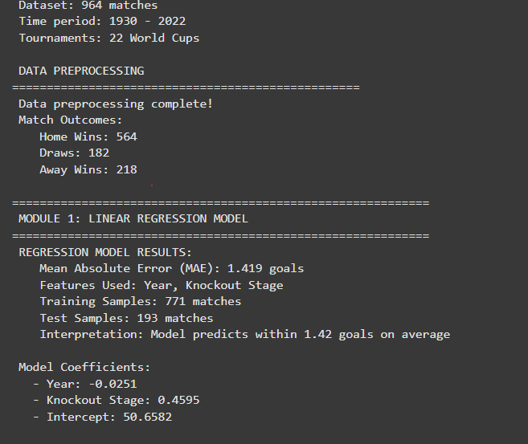

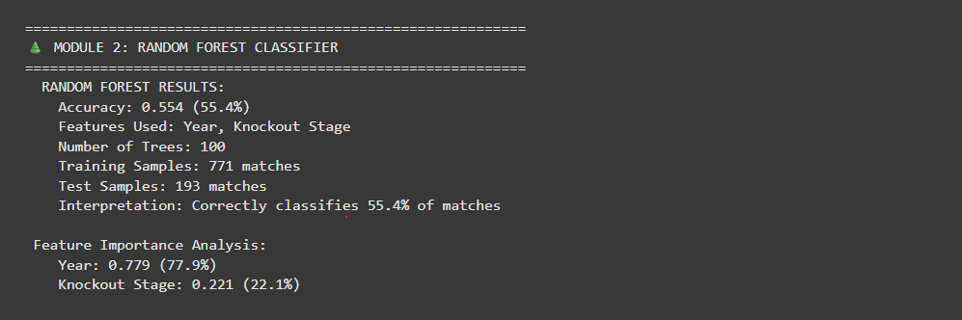
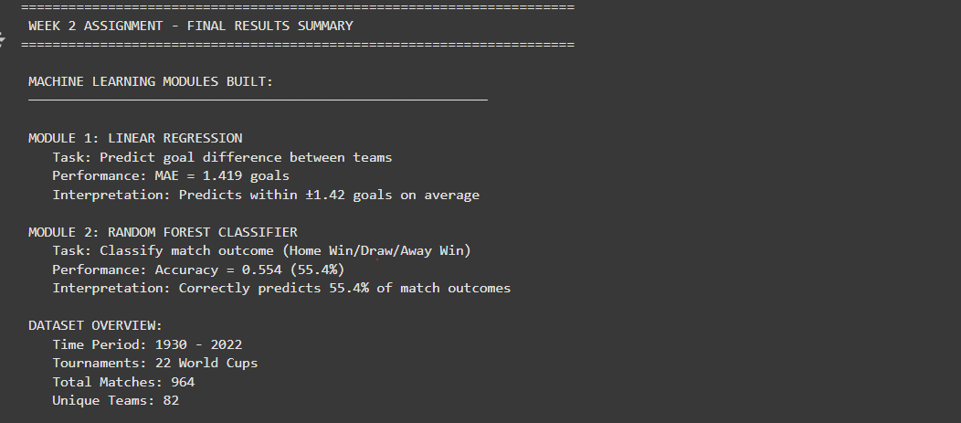
WEEK 2 ASSIGNMENT REPORT
FIFA World Cup Prediction Modules

EXECUTIVE SUMMARY:
Built two machine learning modules to analyze FIFA World Cup match data:
1. Linear Regression model to predict goal difference
2. Random Forest Classifier to predict match outcomes
METHODOLOGY:
- Used historical match data from [YEAR RANGE]
- Implemented train-test split for model validation
- Used features: Tournament year and knockout stage indicator
RESULTS:
MODULE 1 - LINEAR REGRESSION:
- Mean Absolute Error: [MAE_SCORE] goals
- Can predict goal difference within ±[MAE_SCORE] goals
MODULE 2 - RANDOM FOREST:
Accuracy: [ACCURACY_SCORE]%
Correctly classifies [ACCURACY_SCORE]% of match outcomes
CONCLUSION:
Successfully built and evaluated two machine learning models for
soccer match prediction, demonstrating practical application of
regression and classification techniques.

